**ISO8583 FINANCIAL PROTOCOL INTRODUCTION AND SIMULATION**

* **Development**

**Prepared By:**

**Gurpreet Singh**

<https://www.linkedin.com/in/gurpreet-singh-41aab2b5/>

Contents

1. INTRODUCTION 3

2. ISO8583 MESSAGE FORMAT 3

3. ARCHITECTURE: ISO8583 SIMULATOR 4

4. TECHNOLOGIES USED 4

5. ISO8583 SIMULATOR SCREEN 5

6. ISO8583 SIMUALTOR FEATURES 5

6.1 ISO Data Elements Area 5

6.2 CONTROL AREA 6

6.3 OUTPUT AREA 7

6.4 MENU AREA 8

7. MESSAGE SIMULATION 8

# INTRODUCTION

This document describes the ISO8583 Financial Protocol in detail from theoretical and practical perspective. ISO8583 is a financial protocol.

ISO is an international standard organization which has given a ISO8583 to payment industry. Card Issuers, acquirers and payment system leverages ISO8583 International Standard organization for financial transactions across the globe.

Payment systems in the financial industry use ISO8583 message format to communicate the financial transaction in the form of request and responses. ISO8583 is an application layer protocol which travels between systems or networks on top of underlying TCP protocol.

ISO8583 defines a standard which consists of large number of data fields or elements which contain the actual transaction data. These fields remain in all the systems as standard.

# ISO8583 MESSAGE FORMAT

Below diagram shows the TCP packet content of an Financial transaction request or response packet which is based on ISO8583.

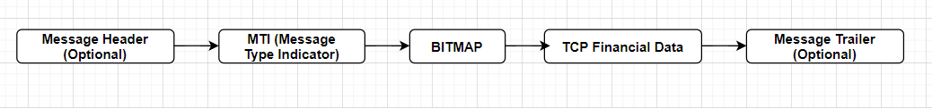

Figure 1: ISO8583 Message Format- TCP

**Note:** I expect you to know the basics of ISO8583 message format and specifications. I will cover the technical and functional details rather explaining the various message format, MTI, Message length types etc.

**Message Header:** This Field is Optional. Some of the custom interface networks like Base 24, POS etc uses Message Headers in the TCP Data. It is up to the parties in case the want the header from the respective interface to make sure it intercepts TCP packet from right source.

**Message Type Indicator**: It is also called as MTI. It is a 4 Byte field which describes the functionality of a message

**BITMAP:** Bitmap is primarily a technique in ISO8583 where every bit serves as an index to represent which data element is present in the TCP Financial Data part of TCP Packet.

**TCP Financial Data:** This represents the actual financial transaction data and details. This part is constructed using various data elements in ISO8583 standard. The field format and length type are taken care in the simulator.

**Message Trailer:** This Field is Optional. Some of the custom interface networks like Base 24, POS etc uses Message Trailers in the TCP Data. It is up to the parties in case the want to understand when to stop reading the TCP byte stream from network in their application.

# ARCHITECTURE: ISO8583 SIMULATOR

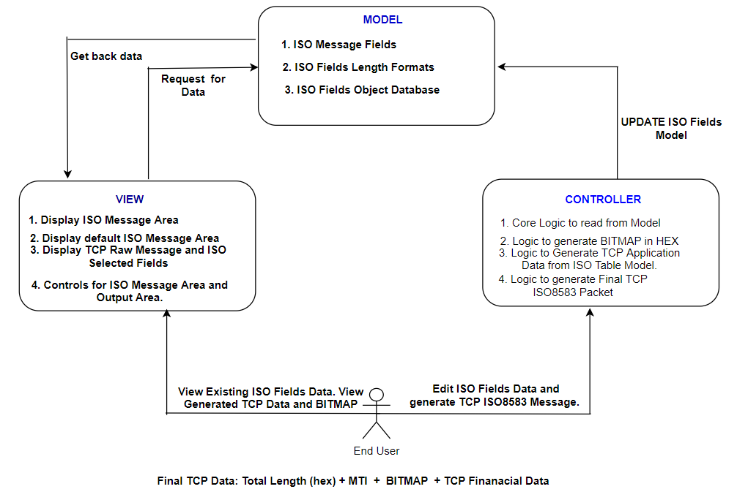

Figure 2: ISO8583 Simulator Java Architecture

# TECHNOLOGIES USED

Below are the list of technologies, architectures or framework and development environment details.

* Java
* Java Swings
* Eclipse IDE
* Java MVC architecture
* Windows 10 64 Bit

# ISO8583 SIMULATOR SCREEN

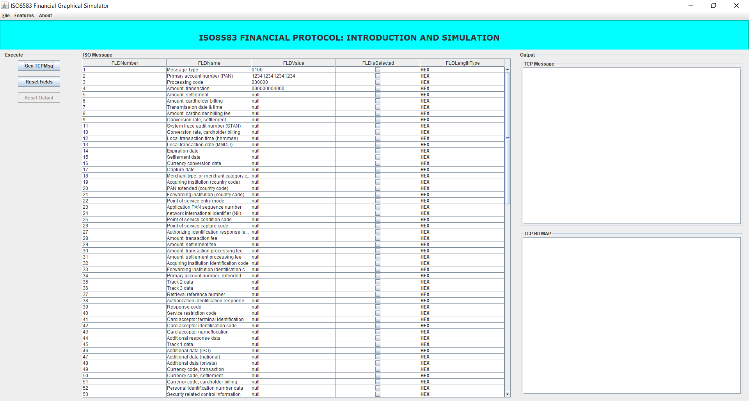

Figure 3: ISO8583 Graphical View

# ISO8583 SIMUALTOR FEATURES

## ISO Data Elements Area

Below screenshot indicate the area where use can enter the data elements for which he or she wants to generate and understand a TCP ISO8583 message. It contains 128 data fields.

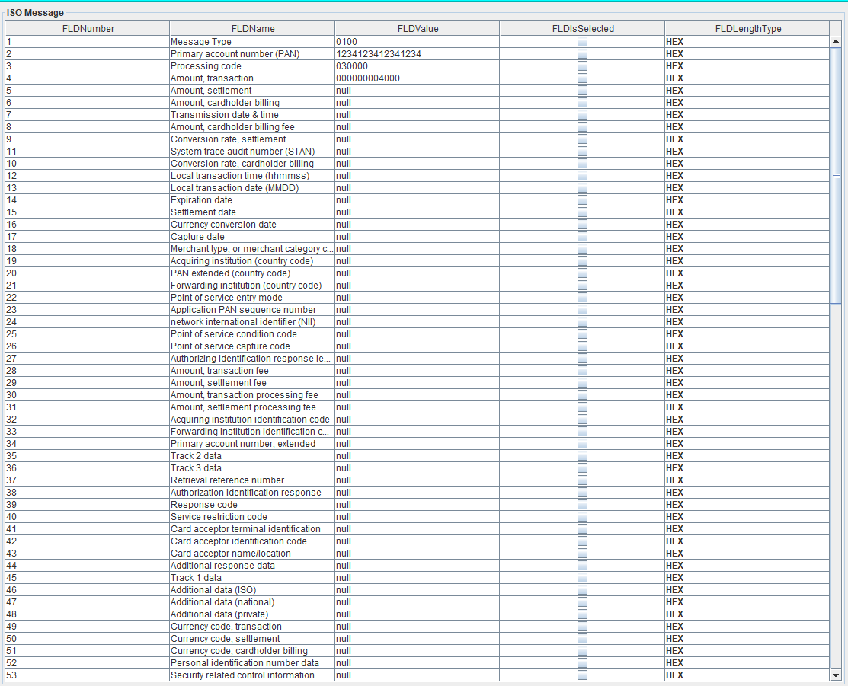

Figure 4: ISO Data Elements Area

## CONTROL AREA

Control area on screen indicates the number of button controls to generate TCP message, reset the existing message and clear the output text area.

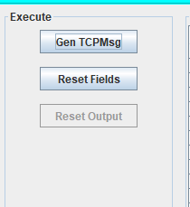

Figure 5: Controls

## OUTPUT AREA

The output area has two text areas on the respective underlying panels to display the TCP Message in RAW format, Selected ISO Fields and TCP BITMAP (PRIMARY OR SECONDARY).

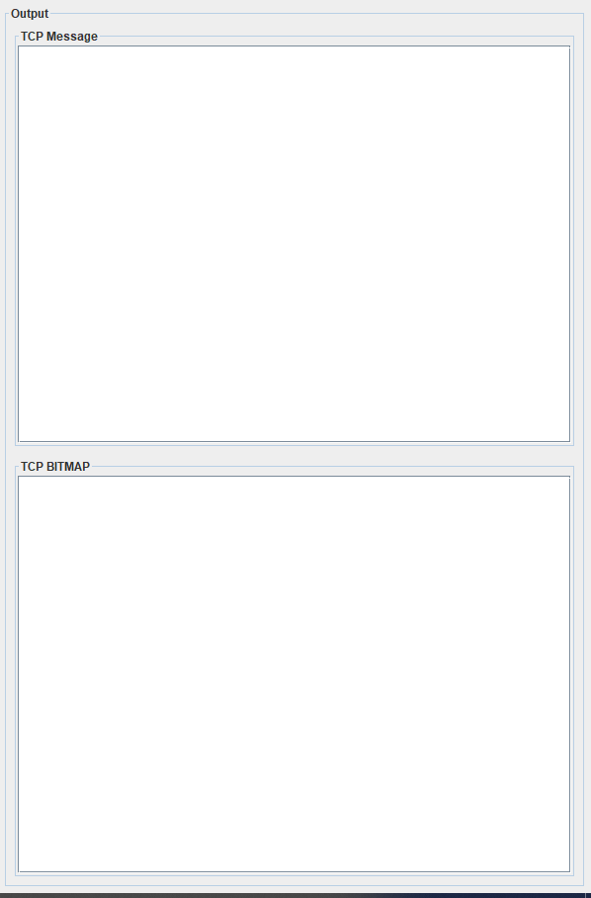

Figure 6: Output Areas- TCPMessage AND TCPBITMAP

## MENU AREA

Please go and explore the menus. It just covers the features and exit the application. The importance is given to the ISO8583 core functionality.

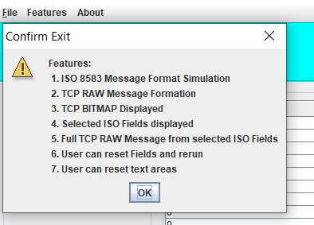

Figure 7:Menu Area

# MESSAGE SIMULATION

**Fields Selected are**

MTI

DE-2: CardNumber

DE-3: Processing Code

DE-4: Transaction Amount

DE14: Card Expiry Date

DE18: MCC

DE41: TERMINAL

DE43: MERCHANT LOCATION

DE49: Currency

DE60: Reserved Data

**Step1: Fields Selected on screen are as below**

Primary account number (PAN)=1234123412341234

Processing code=030000

Amount, transaction=000000004000

Expiration date=2305

Merchant type, or merchant category code=5999

Card acceptor terminal identification=123456

Card acceptor name/location=NOIDA

Currency code, transaction=368

Reserved (national)=1234

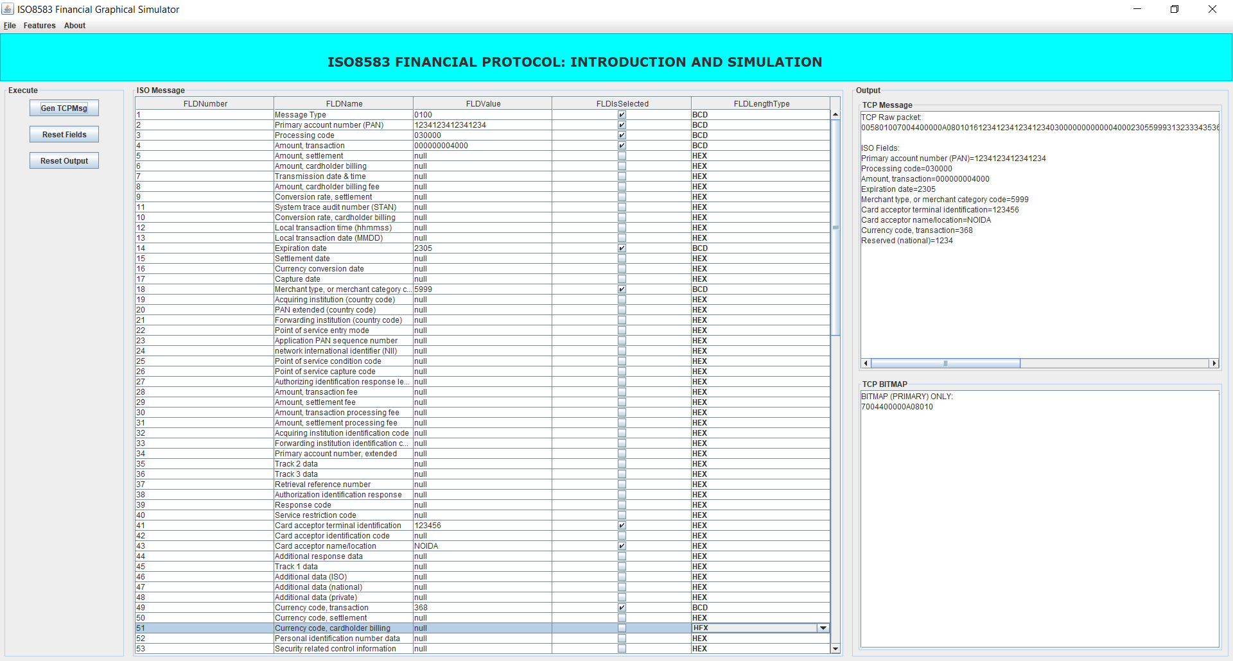

**Step2: TCP RAW Message Generated is as below**

005801007004400000A080101612341234123412340300000000000040002305599931323334353620204e4f49444120202020202020202020202020202020202020202020202020202020202020202020200368000431323334

**TCP message breakup is as below**

**TCP Message Length:** 0058 ( 2 Bytes)

**MTI:** 0100

**BITMAP:** 7004400000A08010

**Bitmap Break up to binary is as below:**

0111 0000 0000 0100 0100 0000 0000 0000 0000 0000 1010 0000 1000 0000 0001 0000 = 64 bits

7 = 0111

0 = 0000

0 = 0000

4 = 0100

4 = 0100

0 = 0000

0 = 0000

0 = 0000

0 = 0000

0 = 0000

A = 1010

0 = 0000

8 = 1000

0 = 0000

1 = 0001

0 = 0000

**Step3: TCPMessage Output Area on Screen**

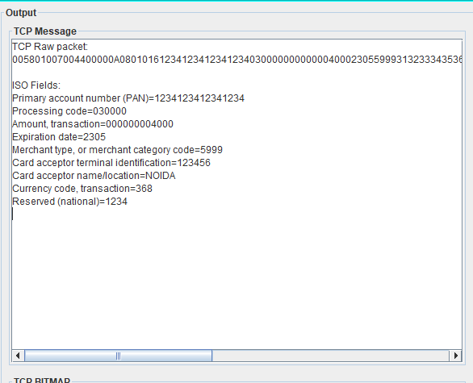

**Step4: TCP BITMAP Area on Screen**

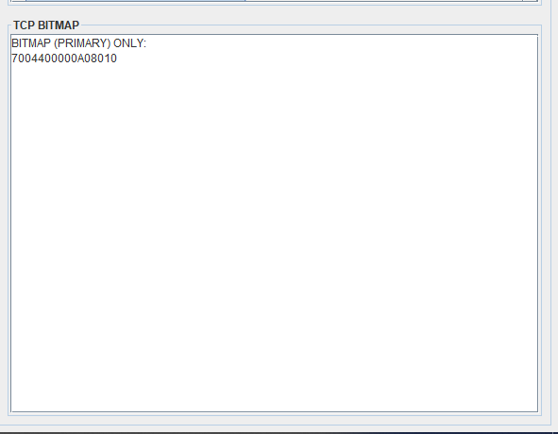

**TCP Financial transaction Data Break up:**

1612341234123412340300000000000040002305599931323334353620204e4f49444120202020202020202020202020202020202020202020202020202020202020202020200368000431323334

Card Number= 16 1234123412341234 (16 = Decimal Length)

Processing Code= 030000 (BCD)

Transaction Amount= 000000004000 (BCD)

Card Expiry= 2305 (BCD)

MCC= 5999 (BCD)

Terminal ID: 3132333435362020 (HEX)

Merchant Location: 4e4f4944412020202020202020202020202020202020202020202020202020202020202020202020

Currency: 0368 (0 padded to make 2 byte)

DE60 Reserved Data: Len= 00 04 (2 Byte, LLVAR), Data= 31323334 (4 Bytes)